**Lab assignment 4**

In our android application, Help!, we utilized Google maps in order to display volunteering locations. This was implemented by adding the Google play services library, and using the following code shown in the screenshots below.

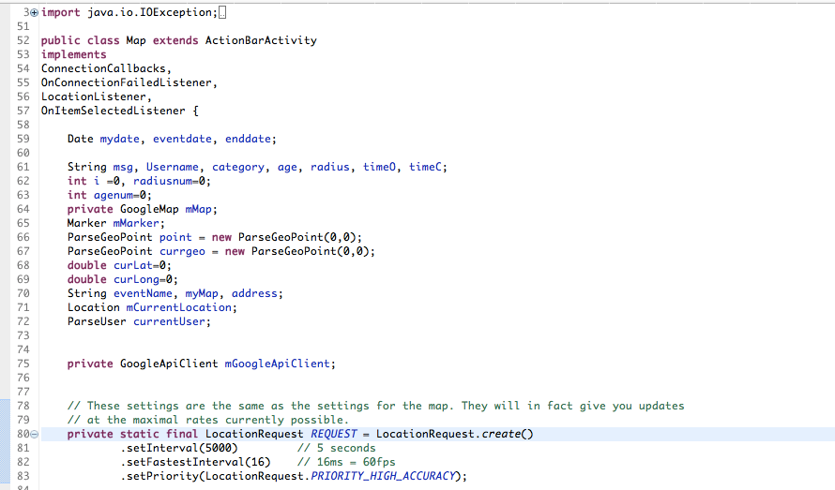

The code first declares all the necessary functions and variables followed by seeing up the map updates requests.

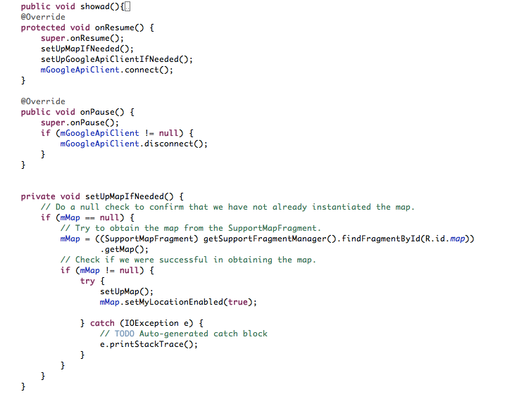

We then go on to create on pause and on resume functions to handle the disconnections and reconnections from the Google maps services as well as prepare how the map is to be set up when needed.

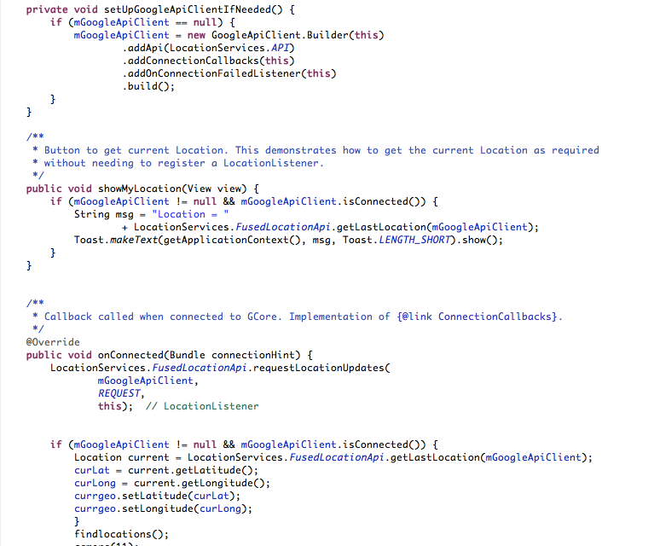

Lastly we set up the google Api client and implement what needs to be done upon connecting to the google api client and setting up the map as well as finding the user’s current location.